
Whareama School
www.whareama.school.nz
Newsletter No. 1
3rd February, 2020
Term 1, Week 1

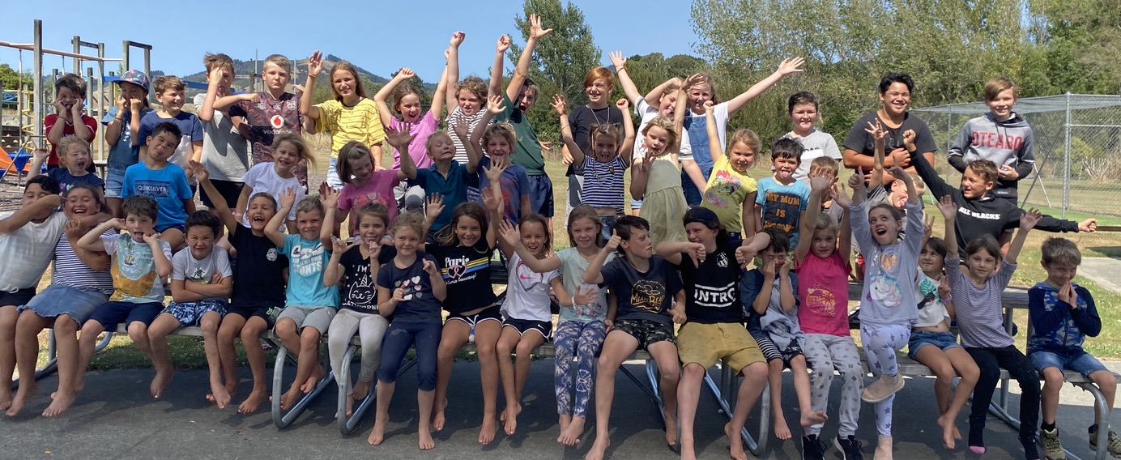

WELCOME BACK
Hi everyone and welcome back to the 2020 school year. We hope you have all had a great break, have managed to recharge the batteries over the holidays, and are set for another big year that has come upon us so quickly. Our starting roll this year is 50, the same starting roll as 2019, and with around 7 enrolments to come in over the year it is going to be a very large roll for us in 2020. A huge welcome to Seb, Archie and Sadie from the Gleeson/ Moorcock Family and Tyson from the Turner family who have all started with us at Whareama. We are excited to be in three learning spaces this year and this is due to our increasing roll, ministry funding and from your Board of Trustees future planning and support of our school programmes. Leading the learning in Timatanga will be Heather Stevens and 12 Year 0-2 students, in Whanake will be Jane Tiley with 15 Year 3 – 4 students and in Whakatutuki will be Sandy Taylor and myself with our 24 amazing Year 5-8 learners. We pride ourselves on allowing plenty of one on one support for students and also for students to be involved in a wide range of opportunities that everyone can take part in. In many larger schools the numbers dictate the need to select certain students for activities, but it is great that we seem to still be able to take everyone to everything. We have a wide range of new initiatives this year and we will attempt to give you a heads-up and brief description of the upcoming events over the next couple of weeks.

SCHOOL CHARTER
We have included the strategic aims from our school charter and it is a direct reflection of our and your ambitions and goals for our students. We have confirmed our new and exciting 2020 – 2022 Strategic Plan and our annual plan is all ready to go, our localised targets will be available soon. The strategic and annual plans will be on the school website from the start of next week. The staff will meet and look over our beginning year data and decide on the focus for our students so we can continue to strive towards achieving the 3 strategic aims. The Board of Trustees have also been involved in the design of our strategic and annual plan and this was guided through my work on the Springboard Trust Leaders programme last year.
Strategic Goal 1:Highly Effective Teaching: All students will leave Whareama School at or above their respective curriculum levels in reading, writing and mathematics.
Strategic Goal 2: Student Agency: All students at Whareama School will be self-managing, independent learners through emphasis on the Key Competencies and values.
Strategic Goal 3: Whanaungatanga: All stakeholders will be actively engaged, knowledgeable and active participants in our school initiatives, student learning and student progress.

CURRICULUM
This year we have decided to run a theme called ‘Wai, Wai, Wai.’ We have a huge variety of science based tasks that we will be working on with the kids and there will be a major focus on water, systems around water and why water is such an important commodity to planet earth. We are planning a wide range of fun, project based activities that will allow the students to develop their own questions and then seek answers to questions, problem solve, explain findings and evaluate their learning. We are studying numeracy, measurement and time in our mathematics unit and our literacy focus this term is guided reading and individualised writing skills. We are doing aquatics and cricket skills for our physical education unit and portraits for art. Our second language programme will focus on Maori history, greetings and classroom instruction. The students will be taking part in a wide range of activities that will involve activities at school and also many activities out of school.

WHANAU DAY
On Thursday the 12th of March we will be having a whanau day that will include a triathlon at school for the kids, a chance for parents to come along and support this as well as a chance to catch up with your teachers and staff. The BBQ will be available if you want to bring a picnic and we also have Jane Mills from Civil Defence who will be doing an emergency hub presentation to the community. The triathlon starts at 3pm and then the classrooms will be open for the afternoon and at 6pm Jane will be presenting in Whakatutuki.

HOMEWORK
All classrooms will be starting homework in Week 3 and this will consist of reading, spelling, mathematics through Maths Buddy or Mathletics and any work that requires completion from unfinished class work. You will also receive a class newsletter from your classrooms next Monday, to outline some of the other bits and pieces of news you may need starting the school year.

DESIGN TECHNOLOGY

This year the Year 7 and 8 students will be going to Design Technology at Makoura College on Fridays from Week 4 this term. There is a separate letter coming home for each of these students later this week to remind you about this programme. The school van leaves school at 10am each Friday and returns in the afternoon for all students. There is no cost for Design Tech this year as our school is part of the Ministry’s new school donations scheme.

STATIONERY
Most of the junior room students have all of their stationery at school however at the end of the year the senior students took home most of their books and stationery. Any books that the children are missing will be supplied to from our stationery cupboard this week. We foresee most students only needing the odd book here and there and this will be a minimal cost added to your account. We would like all children to bring their own felts, colouring pencils, scissors and a glue stick. These are a couple of things that we do not sell through our stationery cupboard at school, so if you could find the time to please go and get these for your children that would be greatly appreciated. If you purchase these from the Warehouse Stationery please nominate our school, it will go towards us getting rewards to spend on resources.

SWIMMING – IN SCHOOL AND LESSONS
Every child in the school will be part of the regular, daily classroom swimming programme so please remember to send them along with their togs and a towel in a swim bag each day. We will be using staff expertise to give the best lessons we can as part of our classroom swimming programmes. We also have a facilitator coming for a professional development day with us on Friday the 21st of February.

KI-O-RAHI COASTAL CLASSIC
On Friday the 6th of March our school is hosting the third annual Ki-o-rahi sports tournament. This will be at Riversdale Beach and will be run with Whaiora from Masterton. We have around 200 students from schools in the Wairarapa coming to this and we will be entering a Year 5/6 team to this event. Unfortunately the Year 7/8 kids will be at Design Tech that day.

2019 SCHOOL TERM DATES
Term 1: Monday 3rd February – Thursday 9th April (Friday 7th and 14th Feb are Teacher Only Days)
Term 2: Tuesday 28th April– Friday 3rd July
Term 3: Monday 20th July – Friday 25th September
Term 4: Monday 12th October – Tuesday 15th December (Friday 23rd October is a Teacher Only Day)


ALSO IMPORTANT
The weather is hopefully going to continue to be better so please sunscreen your children in the morning and ensure they all have their hats at school…..this is a compulsory requirement. We have sunscreen at school as well however if your child has sensitive skin and requires a different lotion please send some to school with them. Ensure lunchboxes are filled with the appropriate foods, no junk food and lollies please and we will only use the microwave in the winter to heat food. Water bottles are essential as well so we can keep the kids hydrated throughout the day…..we are a water only school.

SCHOOL BUSES
As a friendly reminder please remember if there are any changes to what bus you would like your child on please give us at least 24 hours’ notice. There are minimal spaces available on buses at certain times but please ask and we will help where we possibly can. The town bus now has 2 pick up and drop off points in town and these are Henley Lake and the Colombo Road Alleyway. The phone number contacts for the bus drivers are Janelle 0273532329 for the town bus, Darren 0272725532 for the Homewood bus (until a replacement is found) and 3723395 for Brent driving the ICA bus. If your child is not on their bus for any reason please let your bus driver know as soon as possible.

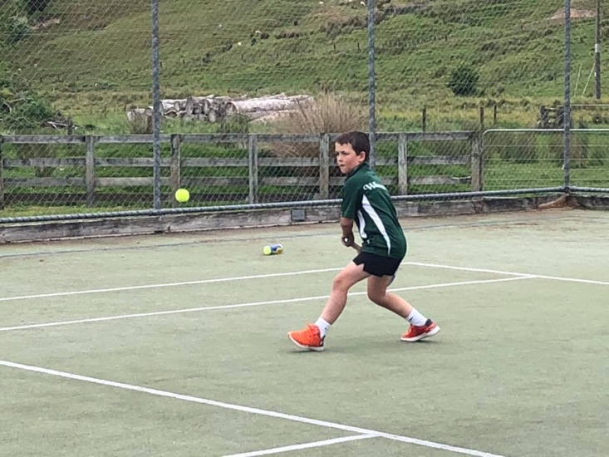
SPORTS
Options for sports will be out later this week and once again we will need some parent support to help run these after school opportunities. Please complete the forms and return to school by Thursday next week. Thanks to Mrs Tiley who is overseeing the sports at Whareama School this year.

MUSIC
Hemi will be starting lessons again in Week 3 (guitar, ukulele, keyboard, singing). If your child took lessons last year they will automatically continue. If you don’t want them to participate or would like any new students added, please ring the office. I am currently in discussion with Hemi re prices and we will let you know by the end of the week.

FORMS
Here is a quick checklist of the forms that have come home today so you can fill in the appropriate form, return them to school by Friday, so we can tidy up the administrative side of beginning the year:
- School Trip Consent Form
- Term 1 Sports Form (later this week)

REMINDER – Thursday 6th FEBRUARY – SCHOOL CLOSED FOR WAITANGI DAY
Friday 7th FEBRUARY – SCHOOL CLOSED FOR TEACHER ONLY DAY
Friday 14th FEBRUARY – SCHOOL CLOSED FOR TEACHER ONLY DAY

NEWSLETTERS
We will now be sending out a school newsletter every second week only. If you would like to receive a paper copy of the newsletter please let Diana know. All newsletters will otherwise be emailed out and they are always available on the school website.
Upcoming Events:
TERM 1:
Thurs 6th February WAITANGI DAY – SCHOOL CLOSED
Fri 7th February TEACHER ONLY DAY – SCHOOL CLOSED
Fri 14th February TEACHER ONLY DAY – SCHOOL CLOSED
Fri 21st February Design Tech Starts – Y7/8
Mon 24th February BOT Meeting – 5.30pm staffroom
Tues 25th February Rural Cluster Swimming Sports
Fri 6th March Ki-o-rahi Coastal Classic
Thurs 12th March Triathlon/ Whanau Evening
Fri 9th April Term 1 Ends

Regards
The Team at Whareama School.

